**Review: States of Matter and Changes of State**

**Read each question. Circle the letter of the correct answer.**

**1.** Which state of matter will take both the volume and shape of the container that holds it?

**A.** ice

**B.** gas

**C.** solid

**D.** liquid

**2.** A child is upset because his ice cream is melting. He thinks he now has less dessert. Which of these explanations correctly states why the child is incorrect?

**A.** No mass is lost during a change of state.

**B.** He actually has more, not less, ice cream.

**C.** The mass will increase if he freezes the melted ice cream.

**D.** Mass is lost only during certain changes of state, such as freezing.

**3.** The illustration shows three different states of a substance.

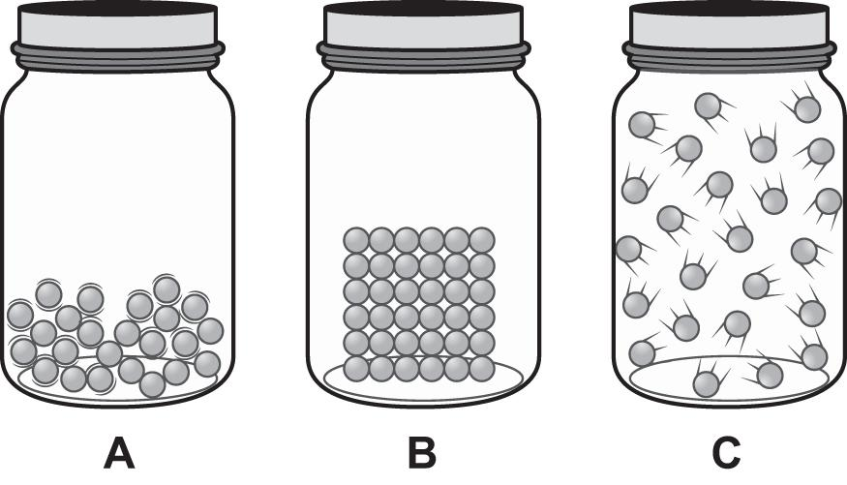

Which of these happens when the substance changes state from the state shown in jar B to the state shown in jar A?

**A.** The particles move more freely.

**B.** The mass of the substance increases.

**C.** The identity of the substance changes.

**D.** The particles expand to fill their container.

**4.** According to kinetic theory, how many particles that make up a substance are constantly in motion?

**A.** all of the particles

**B.** none of the particles

**C.** more than half of the particles but not all

**D.** fewer than half of the particles but more than none

**5.** Which change of state takes place when a gas loses energy?

**A.** melting

**B.** evaporation

**C.** solidification

**D.** condensation

**6.** As water changes state, the water either absorbs or releases energy. Which of these is a process that releases energy?

**A.** ice subliming

**B.** snow melting

**C.** lake water freezing

**D.** ocean water evaporating

**7.** Which of these statements describes a liquid?

**A.** A liquid has a definite volume but not a definite shape.

**B.** A liquid has a definite shape but not a definite volume.

**C.** A liquid has both a definite shape and a definite volume.

**D.** A liquid has neither a definite volume nor a definite shape.

**8.** Ms. Rehak shows her students these models of the three states of matter.

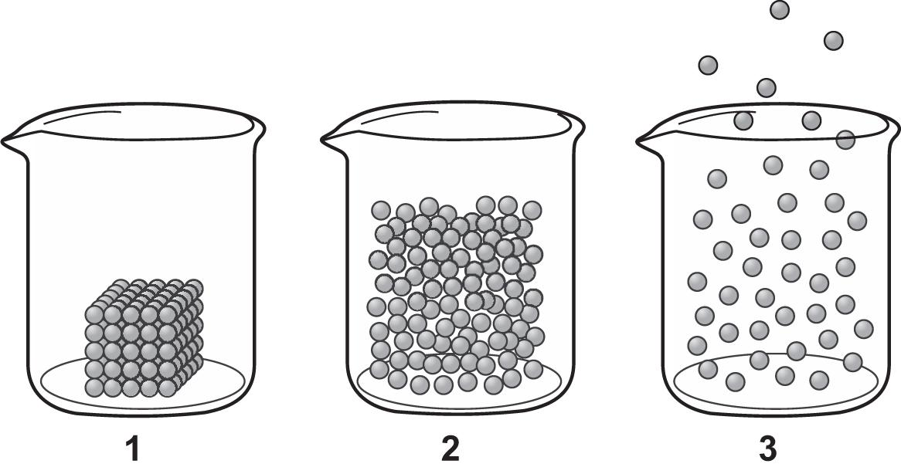

Which of Ms. Rehak’s models represent a gas?

**A.** only 1

**B.** only 2

**C.** only 3

**D.** 1 and 2

**9.** What is the boiling point of water?

**A.** 0° C

**B.** 32° C

**C.** 100° C

**D.** 212° C

**10.** An ice cube is left on a plate and begins to melt. Which best explains how the molecules of water change?

**A.** The molecules began far apart and moving randomly, and end up close together and locked in position.

**B.** The molecules begin far apart and moving randomly, and end up close together but with some room to move.

**C.** The molecules begin close together, with some room to move, and end up close together and locked in position.

**D.** The molecules begin close together and locked in position, and end up close together but with some room to move.

**11.** Which changes of state result in a decrease in the kinetic energy of the particles?

**A.** melting, boiling

**B.** freezing, evaporation

**C.** melting, condensation

**D.** freezing, condensation

**12.** An ice cube melts, and then the liquid water evaporates. Which statement is true about the mass of water that goes through each change of state?

**A.** The mass of the water in each state is the same because mass is conserved.

**B.** The mass of water increases as the water’s volume increases with each change of state.

**C.** The mass of water vapor is less than the mass of ice because some water is lost during each change of state.

**D.** The mass of water vapor is less than the mass of ice because the density of water vapor is less than the density of ice.

**13.** The diagram shows particles in three states of matter.

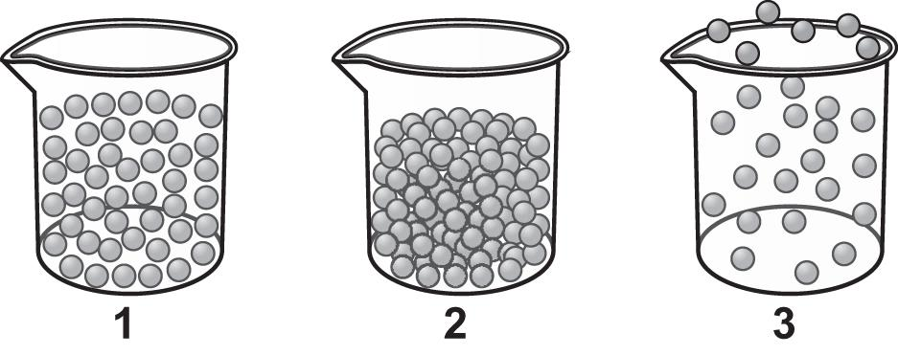

What do each of the states of matter have in common?

**A.** The particles are locked into position.

**B.** The particles in each are in constant motion.

**C.** The particles take the shape of their containers.

**D.** The particles have the same volume in each container.

**14.** Water in a teakettle is heated until it begins to steam. Which best explains how the molecules of water change as the water turns from liquid to steam?

**A.** The molecules begin far apart and moving randomly, and end up close together and locked in position.

**B.** The molecules begin close together and locked in position, and end up far apart and moving randomly.

**C.** The molecules begin far apart and moving randomly, and end up close together but with some room to move.

**D.** The molecules begin close together but with some room to move, and end up far apart and moving randomly.

**15.** As liquid water loses energy in the form of heat, the water begins to freeze. What causes freezing?

**A.** The lost energy causes the bonds between hydrogen and oxygen in the liquid water to break.

**B.** The loss of heat causes the molecules in the ice cube to contract and forces them together.

**C.** Heat removes thermal energy from the liquid water and causes it to become an ice cube.

**D.** The loss of thermal energy from the water causes its molecules to move slower.